**Just IT Data Technician Bootcamp — Summary**

This portfolio summarises my learning journey through the **Just IT Data Technician Bootcamp**, where I developed practical skills in **Excel**, **Tableau & Power BI**, **SQL**, **Azure**, and **Python**.  
Each week focused on a different part of the data workflow — from collecting and cleaning data to analysing, visualising, and presenting it using modern tools.

**Week 1 — Excel**

I completed the **Just IT Data Technician Bootcamp**, where I learned how to work with data step by step. During the course, I practised collecting, cleaning, and analysing datasets in Excel.

1. **Learned about common laws and regulations** that must be followed when working with customers’ data (Data Protection Act, GDPR, Freedom of Information Act, Computer Misuse Act).
   * What each law is about
   * Why it is important
   * A real-world example of how to follow it
   * How it impacts working with data
   * What could happen if it is breached
2. **Worked with the** *retail-sales_dataset.xlsx* **file** — sorted data, used the **SUM** and **AVERAGE** functions, applied filters to show top results, used the **MAX** and **SWITCH** functions, and applied **conditional formatting**.  
   Created a **pivot table** and learned how to use it to analyse and visualise data effectively.
3. **Created different types of charts** — a line chart, a pie chart, and a column chart — and learned how to use them.  
   I discovered that **data visualisation supports analysis and interpretation** by clearly showing patterns, relationships, and trends.

|  |  |
| --- | --- |
|  |  |
| Worked with a pivot table | |
|  |  |

1. **For the final project**, I prepared and presented a **data analysis report** for an imaginary company that was losing customers.  
   I analysed customer data, identified key reasons for churn, suggested improvements, and presented the findings using visual charts and summaries.

|  |  |
| --- | --- |
|  |  |
| Line chart and pivot table | |
|  |  |

**Skill List**

* **Excel:** Pivot tables, formulas (SUM, AVERAGE, IF, SWITCH), charts, and conditional formatting
* **Data analysis:** Cleaning, interpreting, and summarising datasets
* **Analytical thinking** and strong attention to detail
* **Data protection awareness:** GDPR and information security principles
* **Problem-solving** and effective teamwork
* **Adaptability** and time management skills

**Week 2 — Tableau and Power BI**

During the second week of the **Just IT Data Technician Bootcamp**, I learned how to work with **Tableau** and **Power BI** for data visualisation and reporting.

1. Using a dataset, I created my own dashboard that included a bar chart showing percentage changes and a UK map highlighting the main cities affected.

|  |  |
| --- | --- |
|  |  |
| Tableau | |
|  |  |

1. Using the **Spotify dataset**, I analysed the data to identify trends and key insights that could be useful for future organisational projects.
2. I completed several **Power BI labs** focused on loading, transforming, and visualising data, as well as working with **DAX functions** and dashboards.

|  |  |
| --- | --- |
|  |  |
| Power BI | |
|  | |

Report created in Power BI Desktop and published online via Power BI Service.



These exercises helped me understand how to connect datasets, design interactive reports, and apply key analytical tools in Power BI.  
By the end of the week, I felt more confident about turning data into clear visual insights and presenting results in a professional way. Student Performance Word Cloud

|  |  |
| --- | --- |
|  |  |
| Tableau | |
|  | |

|  |  |
| --- | --- |
|  |  |
| Tableau | |
|  | |

**Skill List - Tableau & Power BI:**

* **Data visualisation and reporting** using Tableau and Power BI
* **Creating interactive dashboards** and visual reports
* **Cleaning, transforming, and modelling data** for analysis
* **Using DAX** for calculations, filters, and time intelligence
* **Exploring datasets** to identify key patterns and trends

**Week 3 — SQL**

During the third week of the **Just IT Data Technician Bootcamp**, I learned the fundamentals of **SQL** and how to work with relational databases.

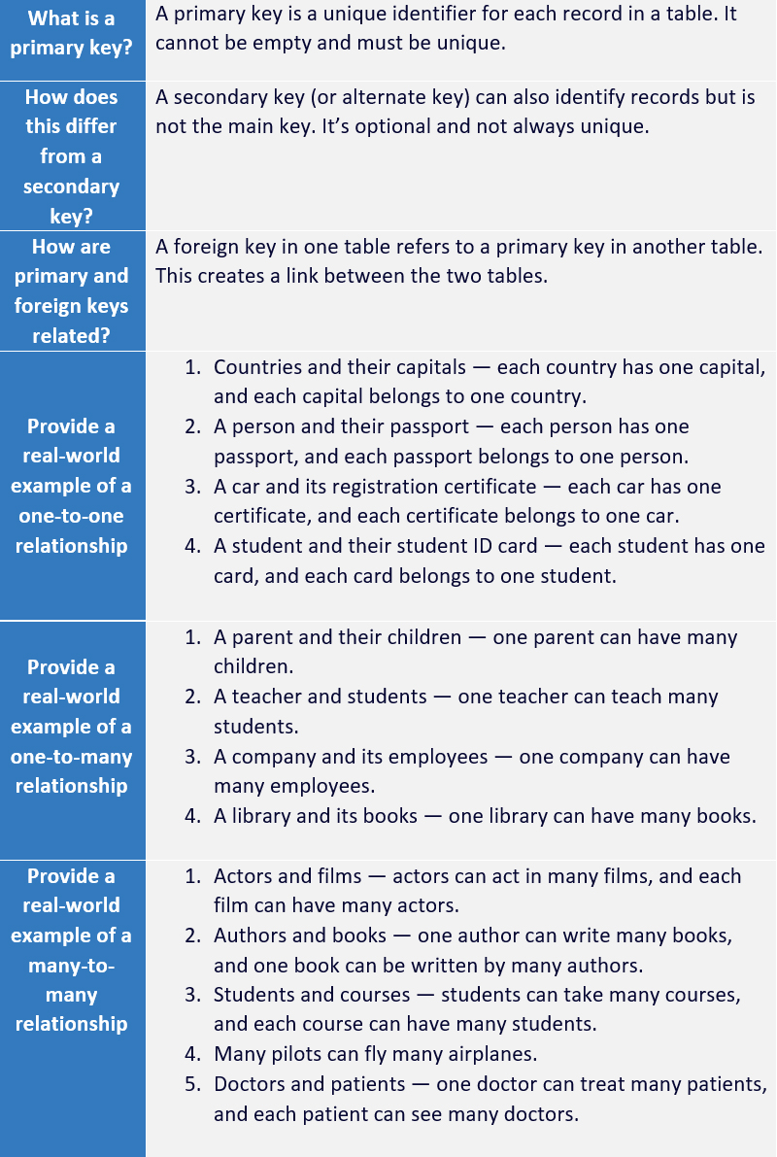

1. **Learned what primary and foreign keys are**, and how they are related.  
   Provided real-world examples of one-to-one, one-to-many, and many-to-many relationships.
2. **Understood the difference between relational and non-relational databases.**
3. **Researched different types of SQL JOINs:** self join, right join, full join, inner join, cross join, and left join.
4. **Database Design Project**

In a group task, we were asked to design a database system for a small retail business that sells groceries and household products.  
The goal was to plan how the database would manage inventory, sales, and customer information, including a loyalty programme.

We discussed and described:

* **Business requirements** – identifying key data to store (products, customers, sales, loyalty points);
* **Database schema design** – creating main tables (Products, Customers, Sales, SaleItems) and defining relationships using primary and foreign keys;
* **SQL implementation** – examples of CREATE TABLE, INSERT, and JOIN statements;
* **Maintenance plan –** checking data quality, saving backups, managing user access, and keeping information secure.

|  |  |
| --- | --- |
|  |  |
| Filling the tables with data | |
|  |  |

Through this activity, I practised **database planning, relational design, and SQL fundamentals**, applying them to a real-world business scenario.

|  |  |
| --- | --- |
|  |  |
| Create database tables and define relationships | |
|  | |

|  |
| --- |
|  |

1. **Final SQL Task**  
   I completed a series of real-world scenarios using SQL queries to explore and analyse demographic and economic data from a global cities database.

The exercises included:

* Counting and filtering cities by population, region, and name patterns;
* Identifying the most and least populated cities and countries;
* Calculating averages and population densities;
* Selecting and sorting data with specific limits;
* Using aggregate functions (COUNT, AVG, MAX, MIN) and conditional filters (WHERE, BETWEEN, LIKE, ORDER BY, LIMIT).

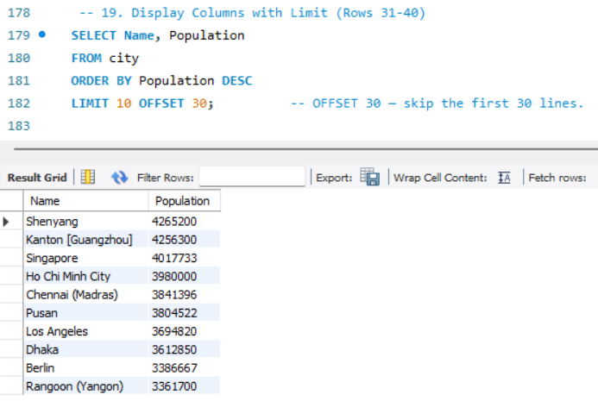

By the end of the week, I gained confidence in creating and managing databases, writing SQL queries, and analysing data from multiple tables.

**Skill List**

* **Database design and structure**
* **Creating tables** and defining **primary and foreign keys**
* **Writing SQL queries** (SELECT, WHERE, ORDER BY, LIMIT)
* **Using JOINs** to combine data from multiple tables
* **Filtering, sorting, and aggregating data**
* **Inserting and updating records** in databases
* **Understanding relationships** (one-to-one, one-to-many, many-to-many)
* **Performing aggregate queries** and grouping results
* **Analysing real-world datasets** to extract insights

**Week 4 — Microsoft Azure**

During the fourth week of the **Just IT Data Technician Bootcamp**, I focused on learning about **Microsoft Azure** and how cloud services support modern data management.  
I studied different types of clouds (public, private, hybrid, community) and cloud service models such as **IaaS**, **PaaS**, and **SaaS**, learning how businesses use them in real-world situations.  
I also explored UK data protection laws, including the **Computer Misuse Act**, **GDPR**, and the **Data Protection Act 2018**, understanding how they **support** the safe use of digital data.

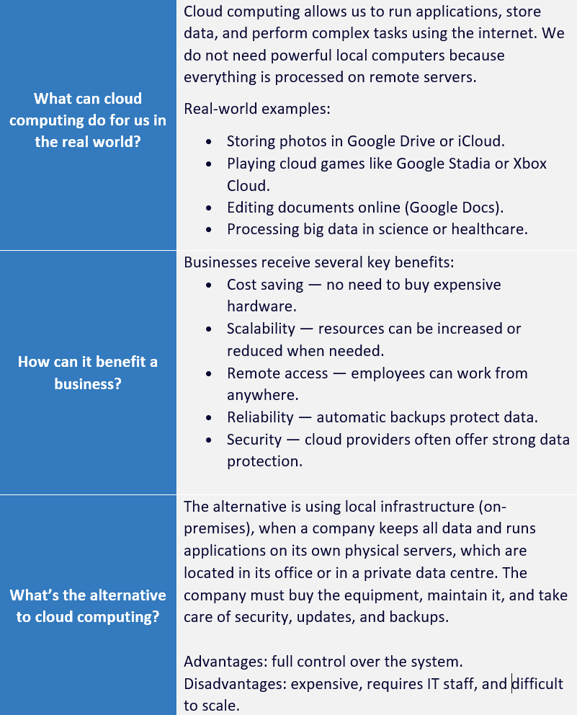

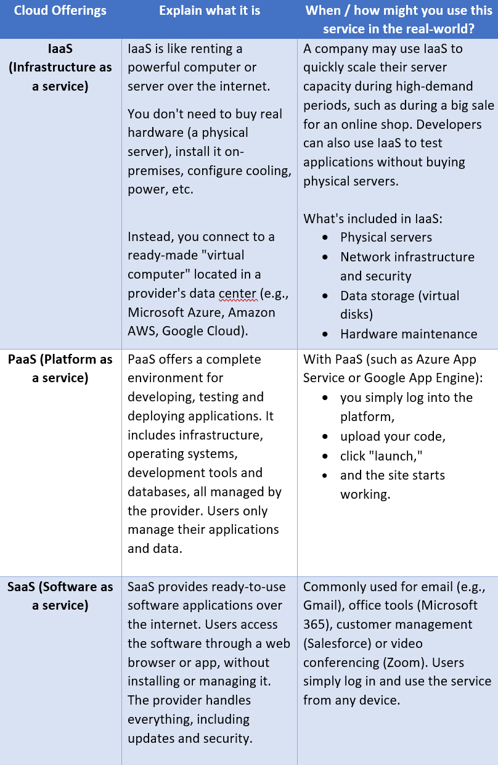

During the labs, I completed Azure learning paths on **relational**, **non-relational**, and **analytical data** in Azure.

As part of a business scenario, I created a report for a small company called “Paws & Whiskers”, explaining how to migrate from Excel to Azure using services such as **Azure SQL Database**, **Azure Data Factory**, **Azure Blob Storage**, and **Power BI**.

**Skill List**

* Understanding cloud computing and its benefits
* Explaining **IaaS**, **PaaS**, and **SaaS** models
* Identifying types of cloud: public, private, hybrid, community
* Knowledge of data protection laws (GDPR, DPA 2018, Computer Misuse Act)
* Using **Azure SQL Database**, **Azure Blob Storage**, and **Data Factory**
* Understanding **relational**, **non-relational**, and **analytical** data in Azure
* Data modelling and migration from Excel to Azure
* Creating dashboards with **Power BI** for business insights

**Week 5 — Python**

During the fifth week of the **Just IT Data Technician Bootcamp**, I learned how to use **Python** for data analysis and automation.  
I started with simple coding tasks such as **FizzBuzz**, where I practised loops, conditions, and logic.

Wrote the code:

* to **import CSV** files into DataFrames;
* to **display** the first 5 rows of a DataFrame;
* to **get information** and summary **statistics** about a DataFrame;
* to **select** specific columns and rows;
* to **add a new column** based on a condition;
* to **rename** and **drop** columns;
* to **group** a DataFrame by a column and calculate the mean mark for each group;
* to **count** the number of students in each class;
* to calculate the **average** mark for each gender;
* to **create a pivot table**;
* to **sort** a DataFrame by the ‘mark’ column;
* **to save a DataFrame to a new CSV file.**

|  |  |
| --- | --- |
|  |  |
| Python | |
|  |  |

**Pie Chart Development Process**

I created a series of pie charts in Python using **Matplotlib** to visualise student performance by grades and gender. The project went through four main versions, each adding new features and improving the design and readability.

**Version 1 – Basic Chart**

* Created a simple **pie chart** showing gender distribution.
* Showed the percentage of each gender.
* This version helped to understand how pie charts represent categorical data.

**Version 2 – First Grade Chart**

* Created a pie chart to show **grade distribution** (A, B, C, D).
* Changed the colour palette to make it clearer.
* Rounded the percentage values to **0 decimal places**.
* Rotated the chart so that it starts from the top and moves **clockwise**.

**Version 3 – Adding Style and Legend**

* Set **specific colours** to each grade manually (to make it easy to find and replace in the future)
* Changed **font size and weight** in the title.
* Added a **legend** explaining what each grade means (A – Excellent, B – Good, etc.).
* Changed the **background colour** for a softer look.
* Hide category labels (A, B, C, D) from the chart since they were already included in the legend.
* This version made the chart more professional and visually appealing.

**Version 4 – Final Version with Data Table**

* Added a **table** next to the chart with all students who received grade **A (Excellent)**.
* Improved the **table layout and design** (font, alignment, and borders).
* Sorted the table by students with excellent results A.
* Fixed a **bug** that affected the display columns C and D on the chart.
* This final version combines visual insights with detailed data, making the chart both **informative and interactive**.

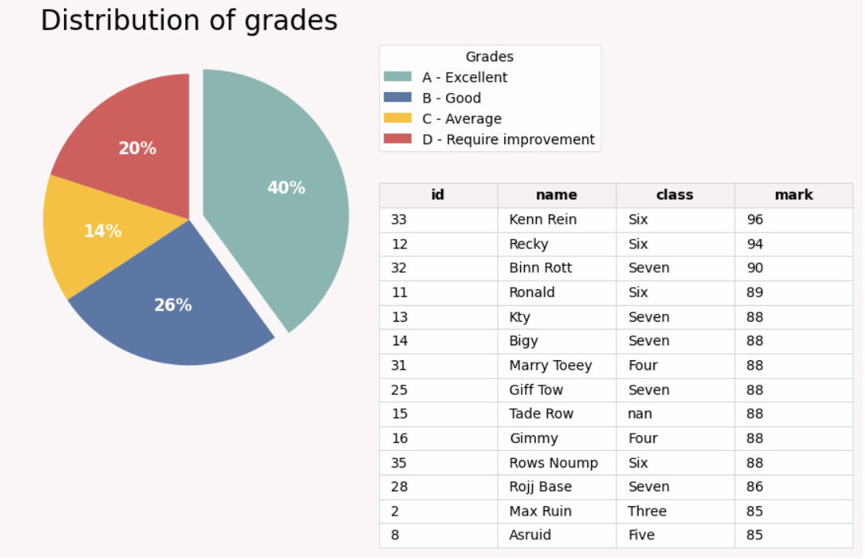

By the end of the week, I was able to clean, transform, and visualise data in Python confidently.

Part 1, Version 4

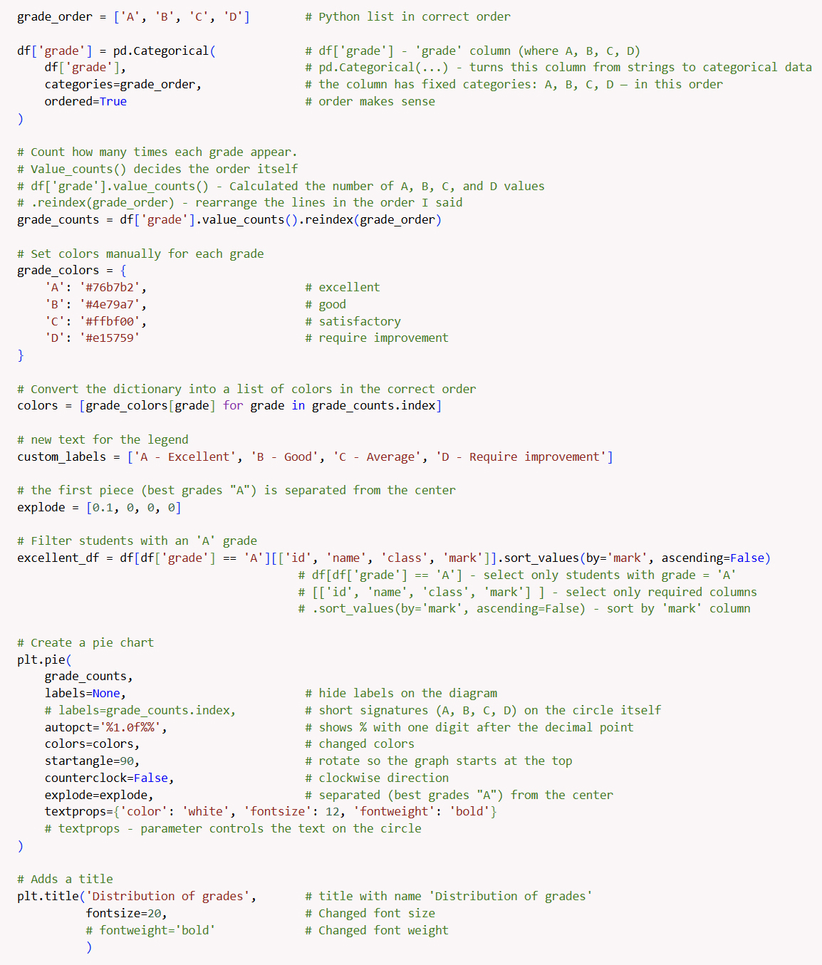

Part 2, Version 4  
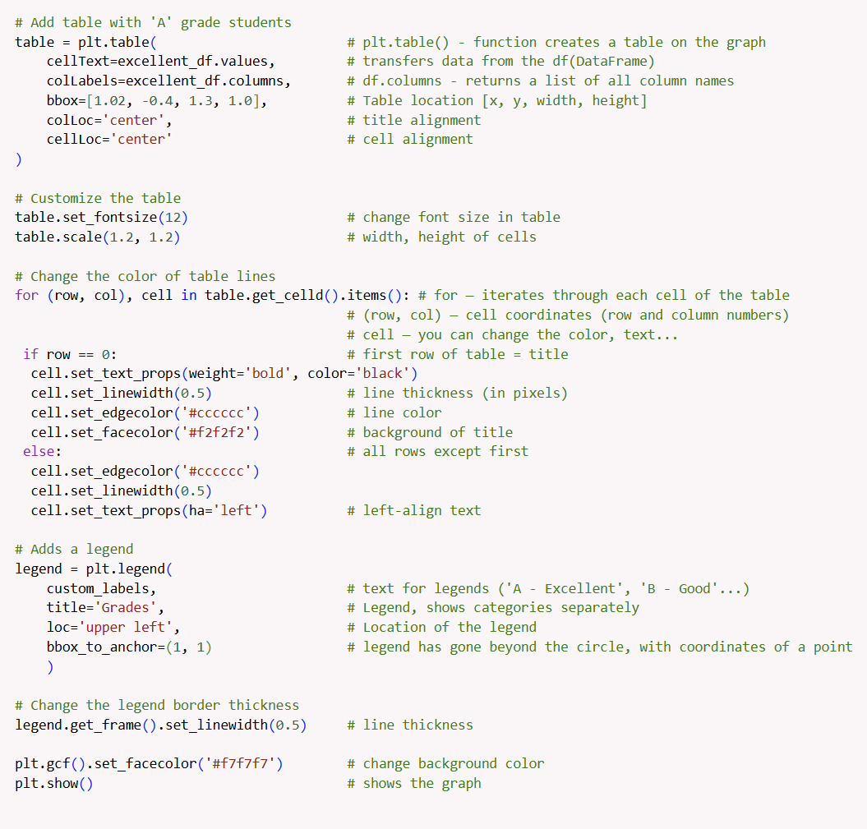

**Skill List**

* Writing basic Python code (loops, conditions, and functions)
* Working with data using **Pandas**
* Importing and exporting **CSV files**
* Filtering, sorting, and grouping data
* Creating new calculated columns and derived fields
* Building **pivot tables** and aggregating results
* Visualising data with **Matplotlib**
* Analysing data patterns, trends, and results
* Using Python for **data cleaning, transformation, and reporting**